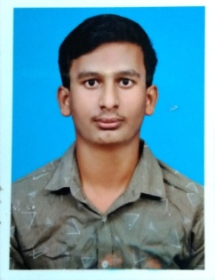**RESUME**

**MANOJ R**

16/96 G1,Attrangal Street,

Ottraiyalvilai,

Kanyakumari Dist., Ph No.: **+917871920080**

Pin: 629702 Email:manojrj2003@gmail.com

**CAREER OBJECTIVE**

To peruse in an organization with performance oriented environment for achievement of personal advancement. Being ambitious & hard working.

**EDUCATIONAL QUALIFICATION**

|  |  |  |  |  |
| --- | --- | --- | --- | --- |
| **Course** | **Institution** | **Board/University** | **Year Of Passing** | **Mark**  **Percentage** |
| B.Sc | S.T. Hindu college, Nagercoil. | M.S University | - | - |
| HSC | Vivekananda Kendra Vidyalaya Matriculation Higher Secondary School Kanyakumari | Tamil Nadu State Board | 2021 | 86.05% |
| SSLC | Vivekananda Kendra Vidyalaya Matriculation Higher Secondary School Kanyakumari | Tamil Nadu State Board | 2019 | 82% |

**TECHNICAL SKILLS**

* python
* java
* ms excel, ms word

**PERSONAL SKILLS**

* Communication
* Sociality
* Self Motivator

**HOBBIES:**

* Reading Books
* Playing Cricket

**PERSONAL DETAILS**

Name : MANOJ R

Father Name : M.RAMESH

Date of Birth : 10/09/2003

Age : 20

Sex : Male

Marital Status : Single

Nationality : Indian

Languages Known: English & Tamil

**DECLARATION**

I hereby declare that the above mentioned information is true and correct to my knowledge.

**Date:** 19.10.2023 Yours faithfully, **Place:** Kanyakumari. (**MANOJ R**)